**Tips:**

Our xxx.pdf document is to provide a bookmark navigation functions.

As follows:

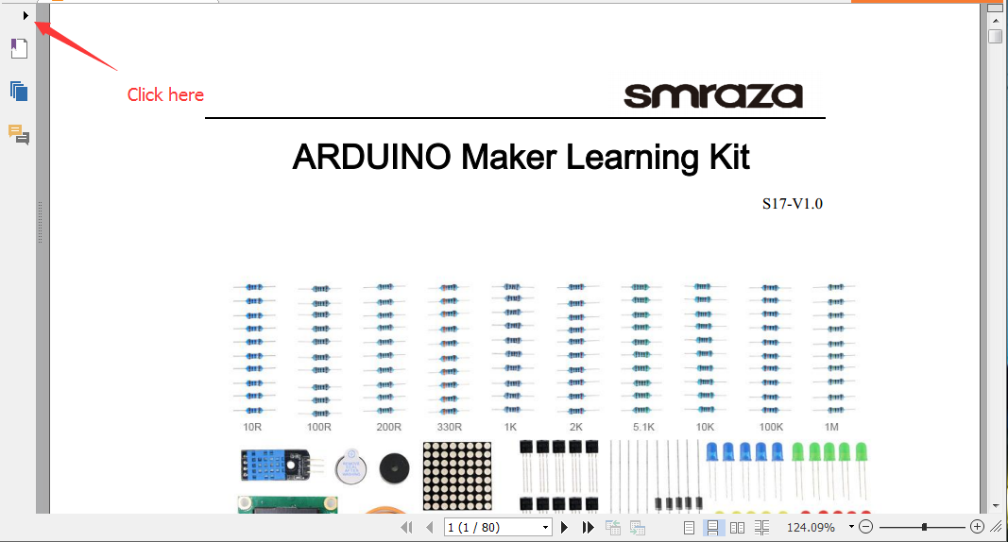

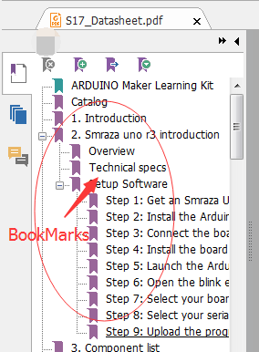

**If you use Adobe Reader, as follows:**

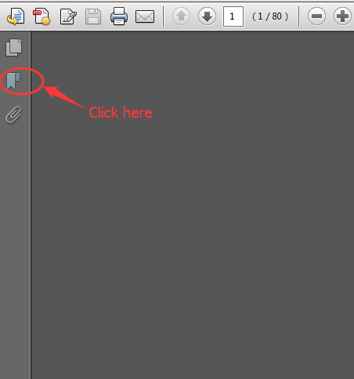

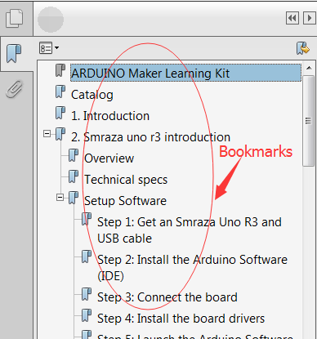

***************************************************************************

* About Smraza:

* We are a leading manufacturer of electronic components for Arduino and Raspberry Pi.

* We have a professional engineering team dedicated to providing tutorials and support to help you get started.

* If you have any technical questions, please feel free to contact our support staff via email at [TechnicSmraza@outlook.com](mailto:TechnicSmraza@outlook.com)

* We truly hope you enjoy the product, for more great products please visit our Amazon store: www.amazon.com/shops/smraza

***************************************************************************